EDS 4900 Project Proposal Draft

Introduction:

I intend to find a way to measure gyroscopic data from a small Quad Copter and use it to optimize the flight of the Quad through the wind. The purpose of this is to increase the flight time of the Quad and to keep the Quad stable during flight. I shall take the gyro data and calculate the sweet spot in how much to have the Quad correct to maintain smooth flight in varying wind speeds, then I can increase the battery life of the Quad.

Method:

I will use a configuration software that comes with the Arduino code from the developer to pull gyroscopic data from the Quad Copter so that I can analyze it. I will find a way, possibly through the development of an algorithm, to use the data to optimize the flight of the Quad in order to increase the flight time and therefore battery life. I have at my disposal for this, a small Quad Copter kit that includes a controller and battery as well as the code that is required to run the copter. I must find a way to gather the gyro data from the software that displays the gyro data so that I can analyze it. I predict that I will be able to get to the point of analyzing the gyro data by February 22nd.

Below is an example of the software that I intend to use to gather gyro data. The chart that can be seen is the live gyro data that I gathered from the Quad. I am still attempting to figure out how to save the data for analysis.

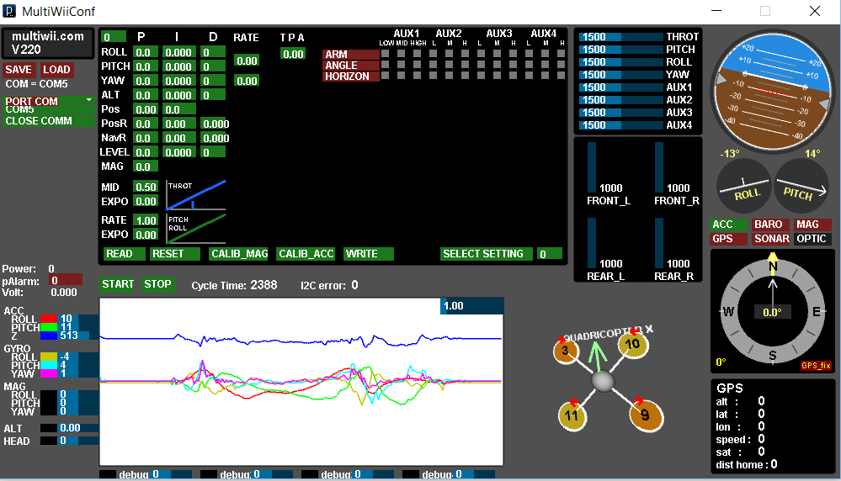

Limitations:

There are certainly some limitations to this project, such as the inability to have chosen the exact Quad Copter for experimentation. Another is the lack of a GPS device integrated into the Quad which would allow for precise flight. A solution is to create a flight plan that can be uploaded into the quad and flown autonomously over and over again to ensure proper data gathering. It is possible that the only way to gather the gyroscopic data will be to have the Quad connected to the computer through a data cable, so I will have to get a long data cable to be able to gather the data while the Quad is in the air performing maneuvers.

Auto tuning for center of gravity

Measure response through gyro to wind

Create filter to measure gyro data

Battery weight to capacity optimization – optimize code